Indian Institute of Information Technology Pune

NAME: Deepesh Patil

GROUP: 2

MIS: 112215055

YEAR/SEM: 3rd Year/5th Sem

ASSIGNMENT: 4

1. System Overview

The Online Course Reservation System will allow students to browse courses, enroll, reserve courses, and manage reservations. Instructors will be able to manage courses, and administrators will oversee users and system functions.

2. Requirements Analysis

• Actors: Students, Instructors, Administrators

• Use Cases:

- Student: Register, Login, Browse Courses, Reserve Course, View Reservations, Cancel Reservation

- Instructor: Log in, Add/Edit Courses, View Reserved Students

- Admin: Log in, Manage Users, Manage Courses, Generate Reports

3. Diagrams (Visio)

3.1 Use Case Diagram

This is an example of how actors interact with the system.

•Steps to Create in Visio:

1.Open Visio and choose UML Use Case template.

2. Add actors (Student, Instructor, Admin) on the left.

3. Insert use cases, for example, Register, Reserve Course, and connect them to relevant actors.

4. Label links to make action clear.

• Components:

- Student Use Cases: Register, Log in, Browse Courses, Reserve Course

- Instructor Use Cases: Log in, Add Courses, Edit Courses, View Reserved Students

- Admin Use Cases: Manage Users, Manage Courses, Generate Reports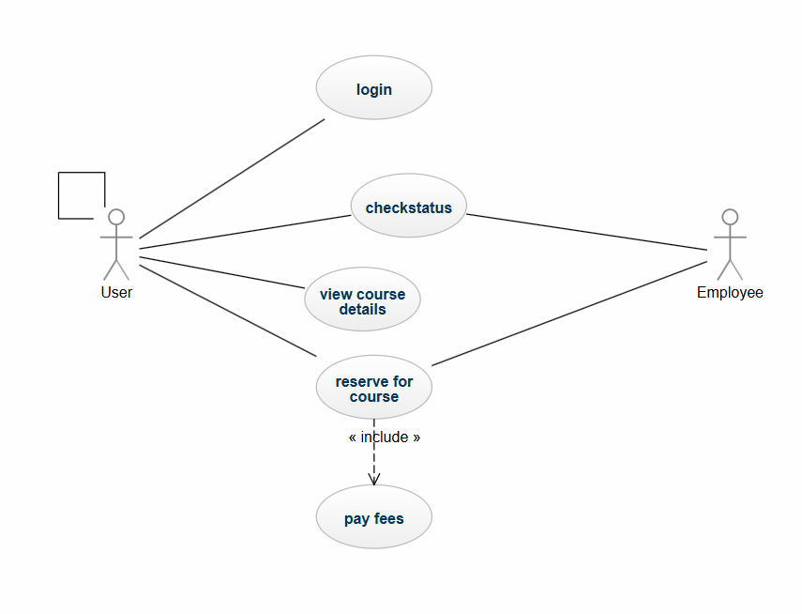

3.2 Class Diagram

It depicts the static structure of the system and highlights classes like Course, User, Reservation.

• Steps to Create in Visio:

Open the UML Class template.

Add classes like User, Course, Reservation.

Define attributes and methods for each class.

Display relationships (e.g., User has a Reservation, Course is related to Instructor).

- Components:

User: userID, name, email, role

Course: courseID, title, description, schedule

Reservation: reservationID, userID, courseID, status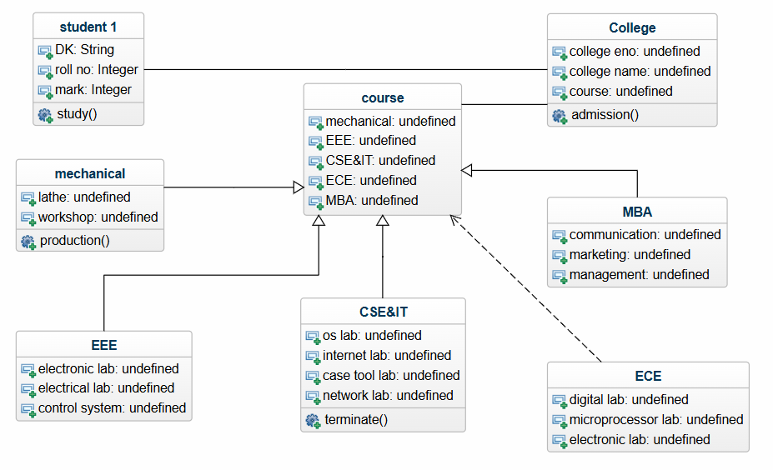

3.3 Sequence Diagram

It is a diagram which shows how a course can be reserved through step-by-step interaction.

- Steps to Create in Visio:

Choose UML Sequence template.

Insert lifelines of objects which participate in the process like Student, Course System, Reservation System.

3. Add messages sent from one object to the other during the process like Student to make a reserve request, the System accepts.

• Process:

Student carries out Reserve Course.

The System verifies if the course could be reserved.

System confirms to the Student if the reservation was successful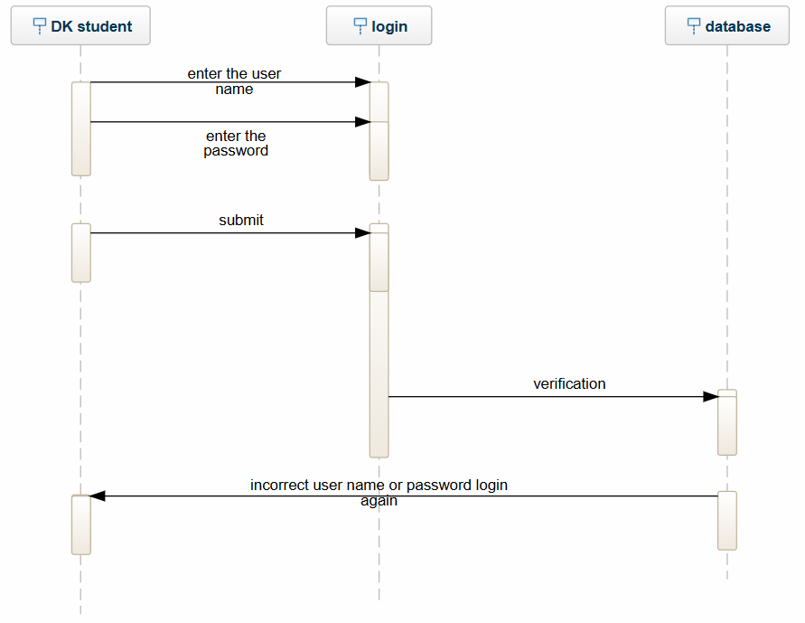

3.4 Activity Diagram

They are meant to display account registration or the whole process of the course being reserved.

- Steps to Create in Visio:

Use the UML Activity template.

Define start and end points.

Add actions-for example, Enter Details, Confirm Email, Complete Registration.

Use decision points for different actions based on conditions-for example, course available or not.

